Policy Brief Template
A Concise, Interesting, and Informative Title
Highlight the first sentence of your introduction by using bold type. An effective introduction grabs your audience’s attention and motivates them to act. Policy briefs should focus more explicitly on implications for a specific policy rather than solely on the research. Describe the problem you wish to address, and help the audience to feel its importance. Provide background information necessary to understand the issue. Offer evidence and/or examples that illustrate the causes and implications of the current situation.
- Summarize 3-5 main ideas that you want your audience to remember, even if they don’t read the rest of the brief
- Weave in recommendations that are clear, easy to understand, and realistic.
- Launch your recommendations with an action verb
- Emphasize key terms with bold type
Key Takeaways
In the second paragraph, you may describe the project or research and what it addresses. This may be a good place to mention your research questions, your project’s focus, and/or your team.
Describe the context of your research on a development challenge, including the individuals or organizations involved, other significant background information, and what the steps are to create change. While you write the brief, consider these questions: What is the situation like now? What needs to change? Who is involved in making the change?
Describe in more depth why the issue is important, and emphasize the essential information your audience needs to know. Focus on plain writing and avoid academic or technical language.
A statement that summarizes your findings relevant to policy
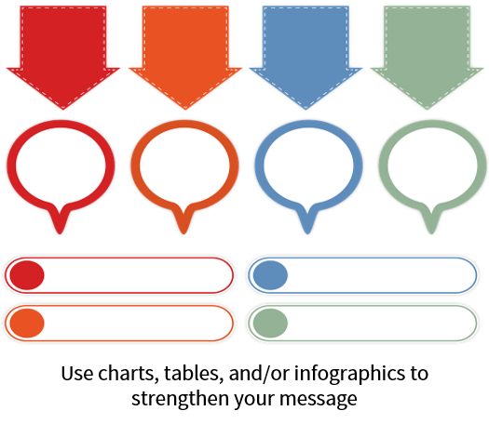
In this section, you’ll describe your project’s most important research finding and related policy recommendations, based on the audience receiving the brief. Remember that a policy brief ultimately is persuasive. Tailor your summary of findings to your audience’s interests and needs. Consider what is most practical and relevant for them to know. Again, focus on plain writing and avoid academic or technical language. Highlight unique methods or data collection, but avoid excessive detail. Your audience is more interested in meaning than method.
Storytelling is a powerful communications strategy. Tell stories that align with your key points and include vivid detail and emotion in order to cause changes in attitudes and/or behaviors. Consider techniques like developing a narrative, tailoring your language to a particular audience, employing metaphors and vivid imagery, and focusing on key individuals related to the project. Bridge with the next section by describing policy implications of your takeaway points.
A statement that summarizes your recommendations for policy
In this section, provide options for potential revisions to policy. Recommendations can include thoughts about policy change, cost for the intervention, how it is delivered, and what cultural considerations are important. Consider what your findings mean for policy decisions and what information will inspire your audience to act. Use active voice with actionable language.
[GRAB YOUR READER’S ATTENTION WITH AN INFLUENTIAL QUOTATION OR CHART, OR USE THIS SPACE TO EMPHASIZE A KEY POINT.]
[Cite your source here.]
Make sure that your research supports the recommendations. Weigh the advantages and disadvantages of the different options, including costs, benefits, and potential side effects. Using evidence and examples, describe the impact of policy revisions and how they can address the issue. Discuss the viability of implementing your recommendations and tie recommendations back to the overall benefit for the issue at hand. What is the overall call to action, and what can the reader do next? If you have space, add in additional support or citations that you consider necessary.
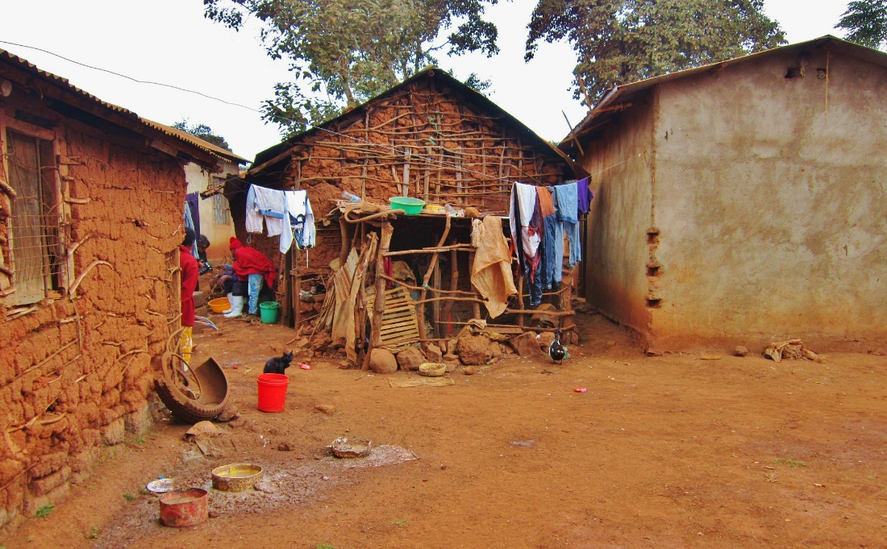
On the bottom right or left, place an image of the team or the project environment with attribution of the key researchers and communities involved. Include a link or contact information for the reader.
Project Name
Main Contact
Phone
Email
Website

