Developing a System-Level View of Complex Challenges*
Activity Worksheets - System Level Analysis (SLA) for Research Question Identification

Overview: The SLA process is applied to assist research/practitioner teams as they design research questions around the existing development priorities of a given USAID partner country, allowing them to generate a strong research proposal that is more likely to result in relevant and applicable research for development. A proper systems-level approach ensures that the teams are considering the many categories of success factors that need to work together to achieve sustainable impact.
This activity framework requires teams to analyze their chosen problem through the lens of 15 success factors. Identifying the relevant missing success factors allows the teams to think intentionally about how to best address these knowledge gaps. Through this process, the teams will develop new research questions – and these research questions will be validated through this systems level analysis. The end result is a more holistic and realistic understanding of the full system that impacts the chosen problem.
Objective: MSI RFA Applicants choosing to use SLA will be able to apply this system-level framework to identify research questions pertinent to a development priority in the USAID partner country of their choice.
Worksheets: You may work directly in this file, or print out each of the three Activity worksheet templates and complete them on pen and paper. The latter may be useful in that it allows you to blow up the size of the templates. Regardless, once the research team has completed the three activities, you will need to make a copy of each worksheet to submit as part of the MSI RFA Letter of Intent (LOI). You do not need to submit individual worksheets, but rather only one composite worksheet developed by the research team that incorporates/synthesizes all input from individual worksheets.

Activity Instructions
For Groups Working on the Same Project | For Individuals
- The research team should determine their chosen problem together. It is essential that they are examining the same problem space. Make sure the chosen problem is clear, specific, and not too large.  - Using this chosen problem, each member of the research team should then complete the SLA Training Worksheets individually.  - Once each member has completed the SLA Training Worksheets, the full team should reconvene to compare their results from Activities 2 and 3. They can use this time to compare their missing success factor categories, their descriptions of the needs within those categories, and their identified research questions. This comparison process will allow them to prepare a final list of new research questions. | - The individual should determine their chosen problem within one of their existing projects. Make sure the chosen problem is clear, specific, and not too large.  - Using this chosen problem, complete the SLA Training Worksheets individually.

Note: The LASER team has provided an overview of the SLA process, including how to complete the Activity worksheets using an example, as part of the first two MSI RFA webinars (November 19, 2021 and December 2, 2021). The SLA section of the webinar has been excerpted for those interested in applying SLA – you can use the video and the included example as a living resource for continual reference; in this way, it serves as a tutorial to help guide research teams as they apply this method.

Activity 1: DEFINING YOUR PROBLEM SPACE
Please identify the development priority to which you will apply the System-Level View. Per the MSI RFA guidelines, this must align with documented country priorities in USAID partner countries; as such, you will want to consult with USAID’s Country Development Cooperation Strategy (CDCSs) for the selected country and/or the USAID Country Mission website. Within the chosen priority area, your team will need to choose a specific problem to examine further. The problem or challenge you choose must be specific, clear, and should not be too large. If you choose a very large problem, the system analysis becomes too broad and is less effective. Using the SLA process to examine this problem through the 15 success factors will allow you to generate new research questions.
- What development priority are you addressing in which USAID partner country?

- Given this priority, what problem or challenge are you examining using the SLA process? The problem space you choose to examine should be both specific and in need of further research.

- Who is the target population that will benefit from solving this problem?

Activity 2: Identifying Missing Success Factor Categories
This Table will help you identify the missing success factors that need to be considered for your problem. For each row, the following instructions explain how to complete the Activity 2 worksheet.
- Is this category required for your work to have an impact? Yes or No. If the answer is “Yes”, move on to the next column. If the answer is “No”, then this category is not required for your chosen problem – move on to the next row (i.e. the next success factor category).
- If you answered “Yes” for #1, then ask: “Is this category currently being adequately addressed?” Yes or No. If the answer is “Yes”, you do not need to consider this category for your problem – go to the next row. If the answer is “No”, move on to the next column.
- Do you have sufficient evidence to address this category? If the answer is “Yes”, you do not need to consider this category for your problem – go to the next row. If the answer is “No”, move on to the final column.
- If you answered “No” for #3, then this category needs to be examined further to determine how it is influencing your chosen problem. Describe what needs to be learned to fulfill the requirements of the category; this could require multiple descriptions of different needs.
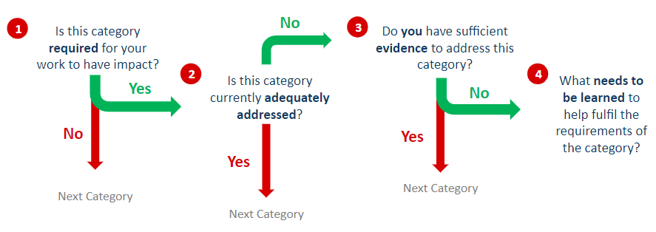
To get a better understanding of each success factor category, you can refer to the short descriptions of the success factors on the next page, or you can use the full Success Factor Tree.

DESCRIPTION OF SUCCESS FACTOR CATEGORIES
Operational components | - Infrastructure development/maintenance to support the needs of beneficiaries in the context of the chosen theme area  - Equipment/Supplies that are required to support development  - Workforce/Talent to cater to the requirements of the beneficiary populations  - Capital/Finances to support activities that advance progress in the problem area  - Practices/Mechanisms that need to be followed to improve existing conditions
Participatory components | - Awareness among intended participatory/beneficiary populations of existing conditions and means to improve them  - Motivation among intended participatory/beneficiary populations to improve existing conditions  - Enabling Strategies to overcome existing barriers that prevent adoption of improved practices  - Adoption/Habit Conversion on the part of engaged populations/stakeholders in favor of behaviors/practices that enable improvement in existing conditions
System robustness components | - Measurement mechanisms for evaluation of progress towards targeted goals  - Mechanisms for Sustainability of various parts of the system  - Resilience capacity to overcome disruptions/disturbances that may hamper progress
Foundational components | - Security/Safety with respect to quality of life and access to resources  - Policies that support advancement in the chosen problem area  - Government/Leadership support and involvement in attaining goals set for the challenge
 | 16. Other – inputs that you feel are not listed above

ACTIVITY 2: IDENTIFYING MISSING SUCCESS FACTOR CATEGORIES TEMPLATE

Use the instructions above (page 4) to determine the success factors categories that need to be examined for your chosen problem.

Category | 1) Is this category required for your work to have an impact? Yes or No | 2) Only use this column if you answered “Yes” for #1. Is this category being adequately addressed, currently? Yes or No | 3) Only use this column if you answered “No” for #2. Do you have sufficient evidence to address this category? Yes or No | If you answered “No” for #3, describe what needs to be learned to fulfill the requirements of this category for your problem. Be as descriptive as possible and identify as many needs as you can.
Infrastructure
Equipment and
Supplies
Workforce/Talent
Finances/Capital
Practices
Awareness
Motivation
Enabling Strategies
Adoption/Conversion of Habits
Measurement & Evaluation
Sustainability
Resilience
Safety/Security
Policies
Government/Leadership
Other

Activity 3: Generate Research Questions
In this final activity, we will use insights gained from Activity 2 to determine potential research questions within the relevant categories. This final activity is completed only for the relevant categories determined in Activity 2, so you will not need to use every row in the Activity 3 worksheet on the next page.
Instructions on how to complete the Activity 3 worksheet:
- First, it is important to re-focus on your chosen problem. The potential new research questions that you identify within the relevant categories must help you address this problem in new ways. Re-write your problem at the top of the page.
- Each of the descriptions you entered in Activity 2 will require more information, either now or in the future. Considering the two questions of the first column will help you identify ways to strengthen the research questions you identify: What actions should I take, or what existing sources should I study, to learn more?
- In this success factor category, what research questions could support the achievement of the larger project goals? These research questions should allow you to gain knowledge that will help address your chosen problem within that specific success factor category.
- Who are potential partners, and what roles would they play?
By identifying relevant research questions within each success factor category, we gain a systems-level view of the different factors that are necessary for sustainable success in any problem space. By addressing these research questions, the research project proposed for the USAID country priority will be able to better address the development needs of a given country and sector.

ACTIVITY 3: TEMPLATE FOR IDENTIFYING RESEARCH QUESTIONS

USING THE MISSING SUCCESS FACTOR CATEGORIES
Write your Problem (see #2 under Activity 1) here:
Category | What actions should I take, or what existing sources should I study, to learn more? | In this success factor category, what research questions could support the achievement of the research project outcomes? | Who are potential partners, and what roles would they play?
Infrastructure
Equipment and
Supplies
Workforce/Talent
Finances/Capital
Practices
Awareness
Motivation
Enabling Strategies
Adoption/Conversion of Habits
Measurement & Evaluation
Sustainability
Resilience
Safety/Security
Policies
Government/Leadership
Other

