Project Summary Template
Insert a plain-language version of your project’s main finding(s) in this space. Tailor the findings to match the needs of the audience.
A Concise, Interesting, and Informative Title
Highlight the first sentence of your introduction by using bold type. Engage your audience’s attention by summarizing your project's main findings and helping the audience to see why they should care. This format runs counter to the ways in which scientists typically are trained. Traditional academic papers begin with background information, move on to supporting details, and finally present their results and conclusions. However, when communicating with other audiences, it is effective to invert this model as shown in the diagram above. Journalists use this inverted model to place results and conclusions—which often are of most interest to non-experts—before more detailed information, such as methodology.
Background
Information
Your second paragraph can provide background information on the research problem you investigated. As you write, consider these questions: What issue has your research addressed and what is the context behind this issue? Identify the development challenge for which your work has designed a solution.
A statement describing your key research focus and context
In an academic paper, the methods section must provide enough information so that the experiment can be duplicated. However, that level of detail isn't necessary in this brief. Describe your research question(s) and general methods, but without the same level of detail as in an academic paper. Use plain language to help your audience understand the key focus on your project and the ways in which your team gathered and analyzed data. The goal is to provide enough information to inspire confidence that your team has been rigorous in its approach. Use this section to connect your research focus to the on-the-ground practice and context of the issue you’re engaging.
A statement summarizing your project’s findings
Present the findings of your study using plain language and vocabulary appropriate to a general audience. Include key data gathered resulting from the methods your team used.
Be concise, and avoid providing data that is not directly related to your main findings.
Use graphic elements to present data more efficiently and effectively. Again, focus on helping non-experts to understand the key findings of the project.
A statement summarizing how results will be applied in practice
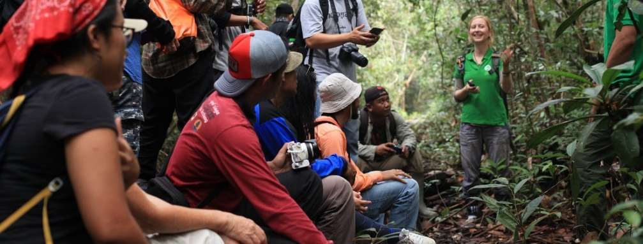
Using plain language, provide an interpretation of your project's findings, and describe their significance to practice in light of what already was known about the problem being investigated. Show your audience how they can act upon your findings. Explain the underlying meaning of your research in terms your audience understands. Help your audience to see how your project advances a development solution as a product, practice, or policy. Encourage their ownership of the problem and its remedies. Provide actions the audience can take to adopt, adapt, or otherwise benefit from this solution. Describe the process of translating research into practice, and specific activities undertaken by your team. Also highlight any research translation and/or community engagement implications or best practices that your audience could utilize. On the bottom right or left, place a picture of the team or the project environment with attribution of the key researchers and communities involved. Also, include a link or contact information for the reader.
Project Name
Main Contact
Phone
Email
Website
As you write, consider these questions:
- What approach did you take to translate your research into practice?
- How did you engage the community?
- Did you develop any regional partnerships?
- What was the role of the implementing partner?
- What worked for you in applying your research to a development challenge?
- What effective steps did you take that would help your project serve as a model for others in the future?

